Machine Learning Coursework 3

1. SVM was used.

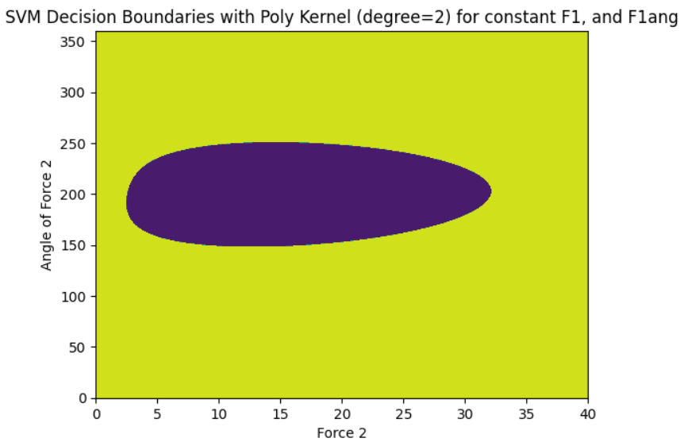

1. The graph using the random forest.
   1. SVM was chosen as it is better.
   2. Pros of using ML
   3. Cons of using ML
2. Analytical calculating the object slip places.

